1. **String vs StringBuilder vs StringBuffer in Java**

A **string** is a sequence of characters. In Java, String objects are immutable, which simply means once created, their values can not be changed. In Java, String, **StringBuilder**, and **StringBuffer** are used for handling strings. The main difference is:

* [String](https://www.geeksforgeeks.org/java/string-class-in-java/)**:** Immutable, meaning its value cannot be changed once created. It is thread-safe but less memory-efficient.
* [StringBuilder](https://www.geeksforgeeks.org/java/stringbuilder-class-in-java-with-examples/): Mutable, not thread-safe, and more memory-efficient compared to String. Best used for single-threaded operations.
* [StringBuffer](https://www.geeksforgeeks.org/java/stringbuffer-class-in-java/): Mutable and thread-safe due to synchronization, but less efficient than StringBuilder in terms of performance.

Difference Between String, StringBuilder, and StringBuffer

|  |  |  |
| --- | --- | --- |
| Feature | Action Class | JavaScriptExecutor |
| **Purpose** | Simulate real user keyboard/mouse actions | Execute JavaScript directly in browser |
| **Keyboard Support** | ✅ Yes (e.g., sendKeys(Keys.ENTER)) | ⚠️ Limited (manual event dispatching) |
| **Real User Simulation** | ✅ Yes | ❌ No |
| **DOM Manipulation** | ❌ No | ✅ Yes |
| **Use Case** | Form filling, keyboard shortcuts | Hidden elements, custom JS events |
| **Reliability** | ✅ High (if element is interactable) | ⚠️ Depends on JS and browser behavior |

Let us consider the code below with three concatenation functions with three different types of parameters, String, StringBuffer, and StringBuilder. Let us clear out the understanding between them via a single Java program below, from which we will be drawing out conclusions from the output generated, to figure out the main differences between String vs StringBuilder, vs StringBuffer in Java.

class Geeks {

// Method 1

// Concatenates to String

public static void concat1(String s1)

{

s1 = s1 + "forgeeks";

}

// Method 2

// Concatenates to StringBuilder

public static void concat2(StringBuilder s2)

{

s2.append("forgeeks");

}

// Method 3

// Concatenates to StringBuffer

public static void concat3(StringBuffer s3)

{

s3.append("forgeeks");

}

// Method 4

// Main driver method

public static void main(String[] args)

{

// Custom input string

// String 1

String s1 = "Geeks";

// Calling above defined method

concat1(s1);

// s1 is not changed

System.out.println("String: " + s1);

// String 1

StringBuilder s2 = new StringBuilder("Geeks");

// Calling above defined method

concat2(s2);

// s2 is changed

System.out.println("StringBuilder: " + s2);

// String 3

StringBuffer s3 = new StringBuffer("Geeks");

// Calling above defined method

concat3(s3);

// s3 is changed

System.out.println("StringBuffer: " + s3);

}

}

**Output**

String: Geeks

StringBuilder: Geeksforgeeks

StringBuffer: Geeksforgeeks

**Explanation:**

* **Concat1**: In this method, the string "Geeks" is passed, and we perform s1 = s1 + "forgeeks". Since String is immutable, a new string is created, and s1 in concat1() points to it. The original string in main() remains unchanged.
* **Concat2:** Here, s2.append("forgeeks") modifies the original StringBuilder object. Since StringBuilder is mutable, it updates the string directly in main() to "Geeksforgeeks".
* **Concat3**: StringBuffer and StringBuilder are similar, but StringBuffer is thread-safe due to synchronized methods, while StringBuilder is not, making it thread-unsafe.

**When to Use Which?**

Geeks now you must be wondering when to use which one, do refer below as follows:

* If a string is going to remain constant throughout the program, then use the String class object because a String object is immutable.
* If a string can change (for example: lots of logic and operations in the construction of the string) and will only be accessed from a single thread, using a StringBuilder is good enough.
* If a string can change and will be accessed from multiple threads, use a StringBuffer because StringBuffer is synchronous, so you have thread-safety.
* If you don't want thread-safety than you can also go with StringBuilder class as it is not synchronized.

**Conversion Between String, StringBuilder, and StringBuffer**

Sometimes there is a need for converting a string object of different classes like String, StringBuffer, StringBuilder to one another. Below are some techniques to do the same. Let's cover all use cases as follows:

* From String to StringBuffer and StringBuilder
* From StringBuffer and StringBuilder to String
* From StringBuffer to StringBuilder or vice-versa

**Case 1: Convert String to StringBuffer and StringBuilder**

This one is an easy way out as we can directly pass the String class object to StringBuffer and StringBuilder class constructors. As the String class is immutable in java, so for editing a string, we can perform the same by converting it to StringBuffer or StringBuilder class objects.

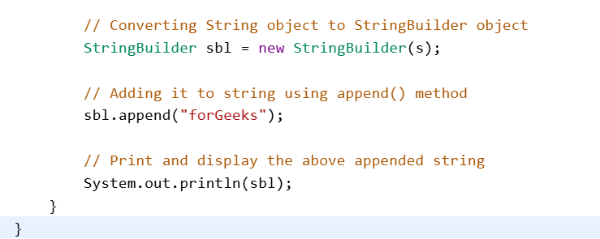



**Explanation:**The above example shows how to convert a String into StringBuffer and StringBuilder. We are reversing the String using StringBuffer and then adds more text using StringBuilder.

**Case 2: Convert StringBuffer or StringBuilder to String**

This conversion can be performed using [**toString() method**](https://www.geeksforgeeks.org/java/class-tostring-method-in-java-with-examples/#:~:text=The%20toString()%20method%20of,returns%20the%20formed%20string%20representation.) which is overridden in both **StringBuffer and StringBuilder** classes. Below is the Java program to demonstrate the same.

**Note**:

While we use *toString()* method, a new String object(in Heap area) is allocated and initialized to the character sequence currently represented by the StringBuffer object, which means the subsequent changes to the StringBuffer object do not affect the contents of the String object.

**Example:**

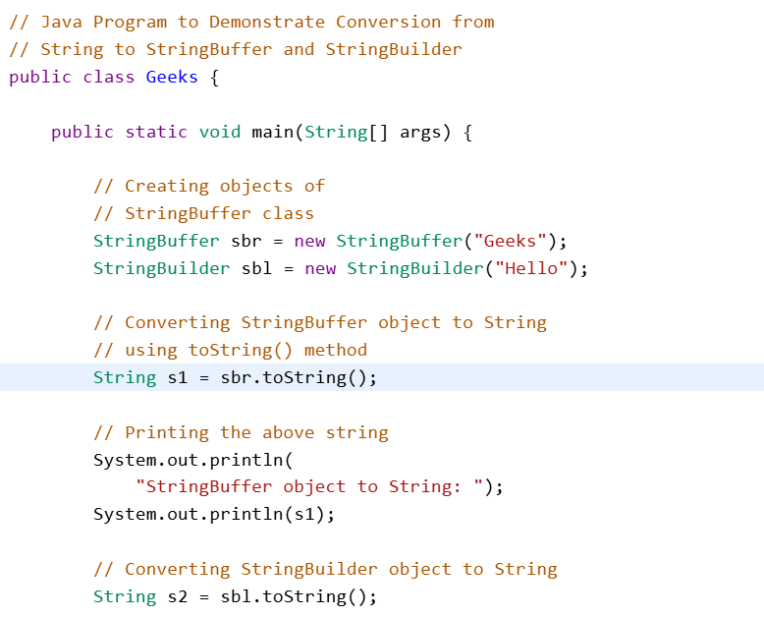

**Output**

StringBuffer object to String:

Geeks

StringBuilder object to String:

Hello

GeeksForGeeks

Geeks

**Explanation:**The above example shows how to convert StringBuffer and StringBuilder objects into String with the help of toString() method.

**Case 3: Convert StringBuffer to StringBuilder or vice-versa**

This conversion is tricky. There is no direct way to convert the same. In this case, We can use a String class object. We first convert the StringBuffer/StringBuilder object to String using ***toString()* method** and then from String to StringBuilder/StringBuffer using constructors.

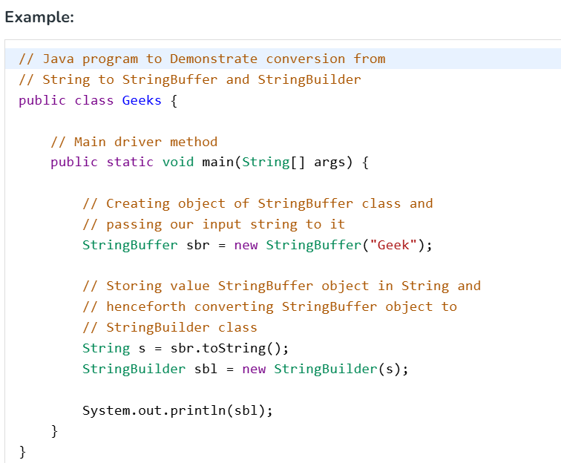

**Output**

Geek

**Explanation:**The above example shows how to convert a StringBuffer into a String and then converting the same String into a StringBuilder.

**Note:**From the above three use-cases we can conclude out below pointers:

* Objects of String are immutable, and objects of StringBuffer and StringBuilder are mutable.
* StringBuffer and StringBuilder are similar, but StringBuilder is faster and preferred over StringBuffer for the single-threaded program. If thread safety is needed, then StringBuffer is used.

**JAVA_ Collections**

**Collections in Java**

A collection in Java is a group of individual objects that are treated as a single unit. In Java, a separate framework named the "**Collection Framework"** was defined in JDK 1.2, which contains all the Java Collection Classes and interfaces.

In Java, the Collection interface (**java.util.Collection**) and Map interface (**java.util.Map**) are the two main “root” interfaces of Java collection classes.

**Needed for a Collection Framework**

Before the Collection Framework (before JDK 1.2), Java used Arrays, Vectors, and Hashtables to group objects, but they lacked a common interface. Each had a separate implementation, making usage inconsistent and harder for developers to learn and maintain.

**Advantages of the Java Collection Framework**

Since the lack of a collection framework gave rise to the above set of disadvantages, the following are the advantages of the collection framework.

1. **Consistent API:**Interfaces like List, Set, and Map have common methods across classes (ArrayList, LinkedList, etc.)**.**
2. **Less Coding Effort:** Developers focus on usage, not designing data structures—supports OOP abstraction.
3. **Better Performance:** Offers fast, reliable implementations of data structures, improving speed and quality of code.

**Hierarchy of the Collection Framework in Java**

The Collection interface extends Iterable and serves as the root, defining common methods inherited by all collection classes.

